A Project Report on

Online Food Ordering System

By

**Tushar Rajendra Jagtap**

MCA – I

Sem-I

2020-2021

(University Roll No: 25097)

To

Savitribai Phule Pune University

Pune- 411041

In Partial Fulfillment of the Degree of

Master in Computer Application (M. C. A.)

Under The Guidance Of

**Prof. Dr. Ramesh Jadhav**



Sinhgad Technical Education Society’s

SINHGAD INSTITUTE OF MANAGEMENT,

Vadgaon Bk, Pune

(Affiliated to Savitribai Phule Pune University, Approved by AICTE

& Accredited by National Board of Accreditation, New Delhi)

**Index**

|  |  |
| --- | --- |
| **Chapter** | **Page number** |
| **CHAPTER 1 : INTRODUCTION** | |
| 1.1 Existing System | **3** |
| 1.2 Need for System | **3** |
| 1.3 Operating Environment Hardware and Software | **4** |
| **CHAPTER 2 : PROPOSED SYSTEM** | |
| 2.1 Proposed System (Introduction of system) | **5** |
| 2.2 Module specifications (Scope) | **5** |
| 2.3 Objectives of System | **6** |
| **CHAPTER 3 : ANALYSIS & DESIGN** | |
| 3.1 Use Case Diagrams | **7** |
| 3.2 Activity Diagram | **8** |
| 3.3 Class Diagram | **10** |
| 3.4 Module Hierarchy Diagram | **11** |
| 3.5 Table specifications (Database design) | **12** |
| **CHAPTER 4 : USER MANUAL** | |
| 4.1 User Interface Screens (Input) | **14** |
| 4.2 Output Screens with data | **14** |
| 4.3 Sample program code | **22** |
| 4.4 Limitations and Bibliography | **30** |

**CHAPTER 1: INTRODUCTION**

* 1. Existing System :-

In the present scenario people have to physically visit the hotels or restaurants for eating food, and have to make payment through cash mode most of the times due to unawareness of advanced technologies at certain places.

In this method time as well as physical work is required, among which time is something that no one has in ample amount. The traditional food ordering procedure is not efficient enough for hotels and restaurant, as they have to deal with crowd, in their restaurant.

The old methods can be classified into categories which are paper grounded and verbal grounded. For paper based work, the waiter comes and pens down foods that customers order and pass the food list containing paper to the chefs or cooks in the kitchen for further process.

Also from the owner’s point of view maintaining data record and the accounts in physical file is bulky and boring work to do. And also it is full of risk as anyone can access it and modify the data.

1.2 Need for System:

Due To this Covid-19 situation many hotels are closed, and so many hotel workers are jobless. This website helps both customers and hotel owner and also gives job opportunity to workers.

This website will be a solution for hotels because in this covid-19 pandemic, Government allows only parcel service. So by using this website customers will get food at any time and according to their convenience and also save traveling time of customers.

There are so may offers and discount so that customers will get best food in low price

By using this website hotel owner will also track food orders and how much money earned and it also reduce maintenance cost of hotel.

1.3 Operating Environment Hardware and Software:

Hardware/Software Interface:

This section lists the minimum hardware and software requirements needed to run the system efficiently.

Hardware Interface:

• Pentium Processor

• 60 MB of free hard-drive space

• 128 MB of RAM

Software Interface:

• Operating System: Windows (Vista/7 or above)

• Web Browser: IE 10 or above, Mozilla FF 31 and above or Google Chrome

• Drivers: Java Runtime Environment

• Integrated Development Environment: Eclipse J2EE or Apache Tomcat

**CHAPTER 2: PROPOSED SYSTEM**

2.1 Proposed System (Introduction of system):

The Online Food Ordering System can be defined as a simple and convenient way for customers to purchase food online, without going to the restaurant.

This system is enabled by the internet – it is the internet that connects the restaurant or the food company on one hand, and the customer on other hand.

Therefore, as per this system, the customer visits the restaurant’s website, browses through the various food items, combos available there and goes ahead and selects and purchases the items he or she needs.

These items will then be delivered to the customer at his or her doorstep at the time they choose by a delivery person.

Payments for such online orders can be made through debit cards, credit cards, cash or card on delivery.

This system for online food delivery is completely safe, secure and is a very popular method.

2.2 Module specifications (Scope):

Scope:

Food Ordering Website can sale Food for Customer’s, through online. It provides you with a convenient way to sale your Food on Website.

This Website make easy for user to buy Food from Restaurant with easy steps can get easy order.

Modules

1. Admin Module:

* Complete access to the website.
* Can add, Remove, Update Food Item’s.
* Check and Remove Users.
* Check Total Orders and waiting Orders.

2. User:

* Limited Access to the website.
* Can register, Login and Forgot password.
* Add food to cart, update Quantity and Place Order.
* Online Payment.
* Give Feedback.
* Can update the information provided.

2.3 Objectives of System:

The main purpose of an online ordering system is to provide customers for a way to place an order at a restaurant over the internet.

The main reason is that it benefits both the customer and the business.

With a website, customers can easily browse all the dishes the restaurant has available; customize dishes to their requirements and place an order. It can also save their favorite orders allowing them to easily re-order that in the future.

From the restaurants perspective, they no longer spend time taking the customer’s order, stop worrying about communication errors and streamline their order management workflow.

**CHAPTER 3 : ANALYSIS & DESIGN**

3.1 Use Case Diagrams

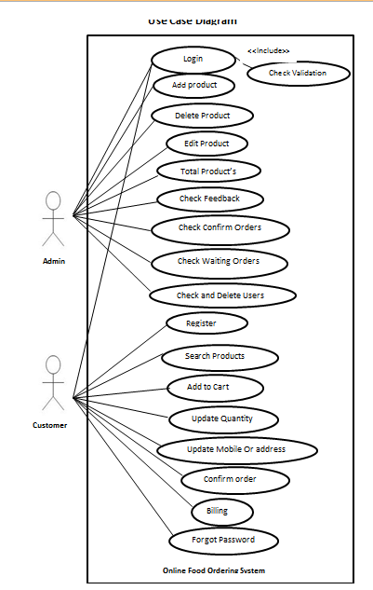

3.2 Activity Diagram

Customer

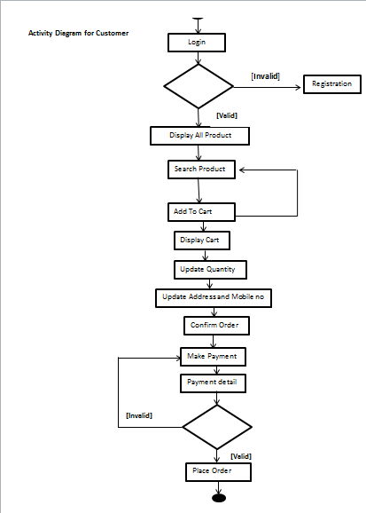

Admin

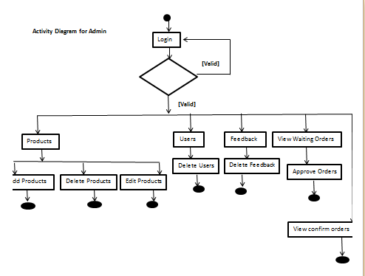

3.3 Class Diagram

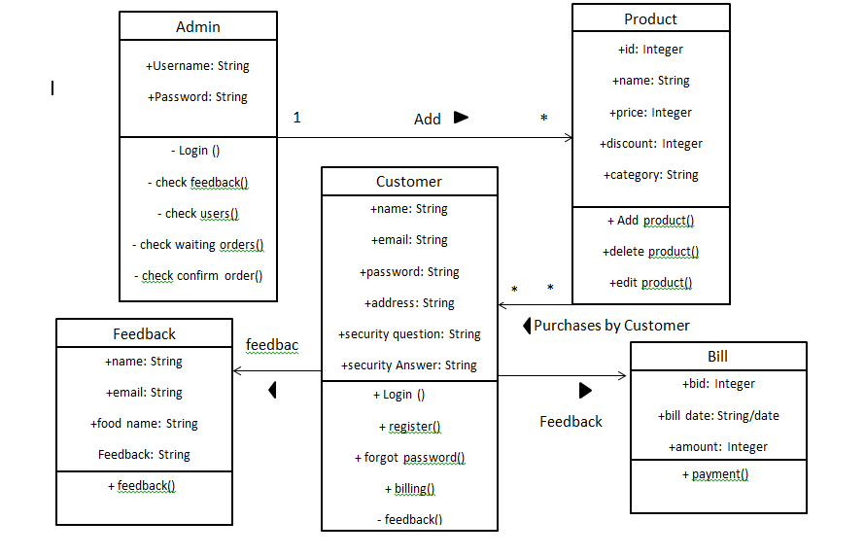

3.4 Module Hierarchy Diagram

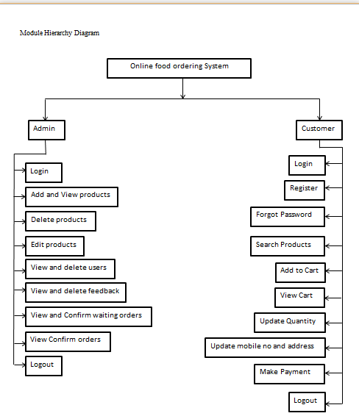

3.5 Table specifications (Database design)

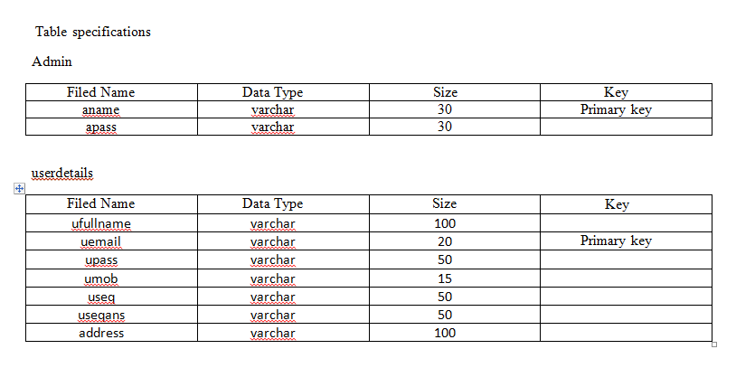

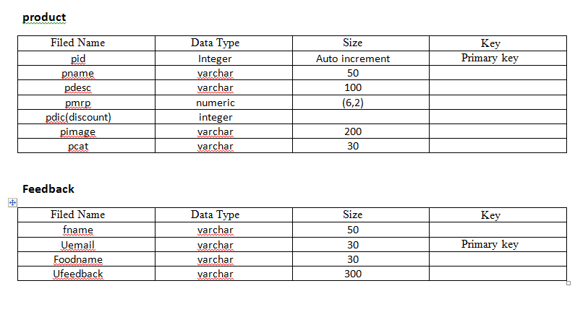

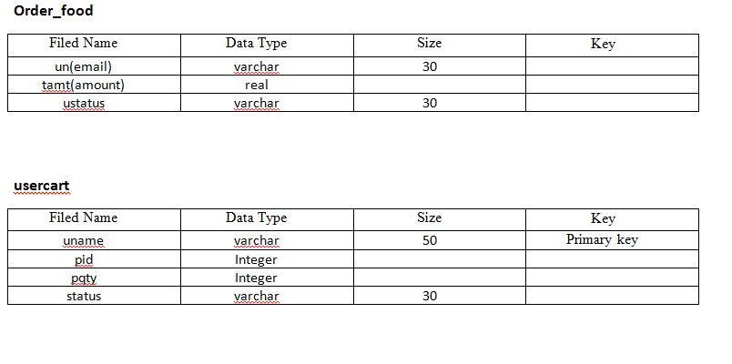

4.1 User Interface Screens (Input)

And

4.2 Output Screens with data

Admin Side

Admin Login

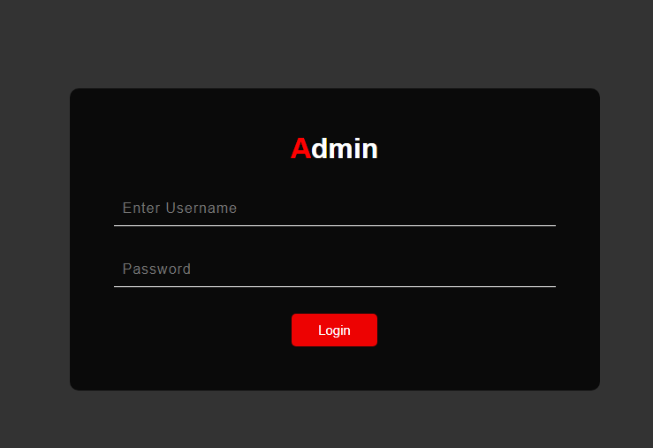

Admin Dashboard

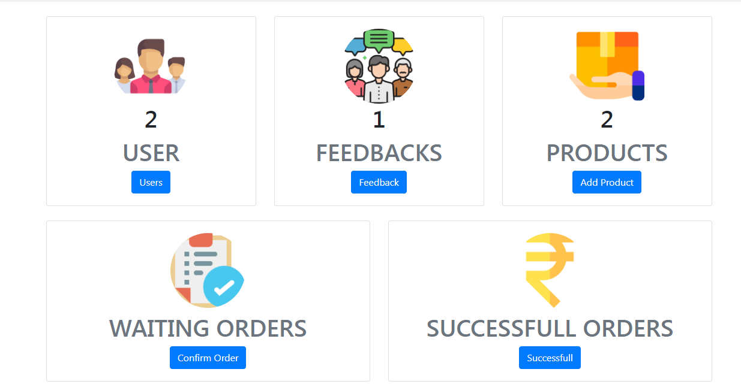

Users

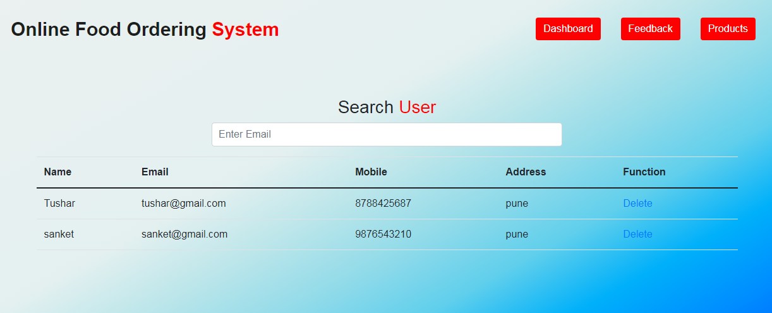

Feedback

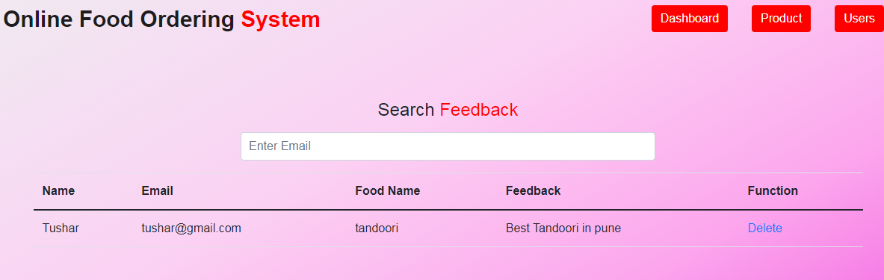

Product

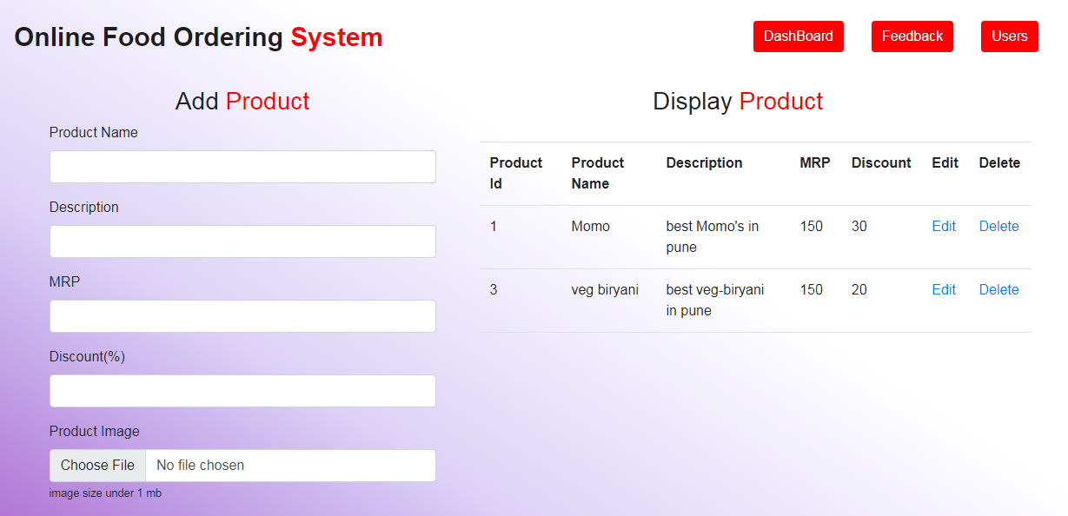

Edit Product

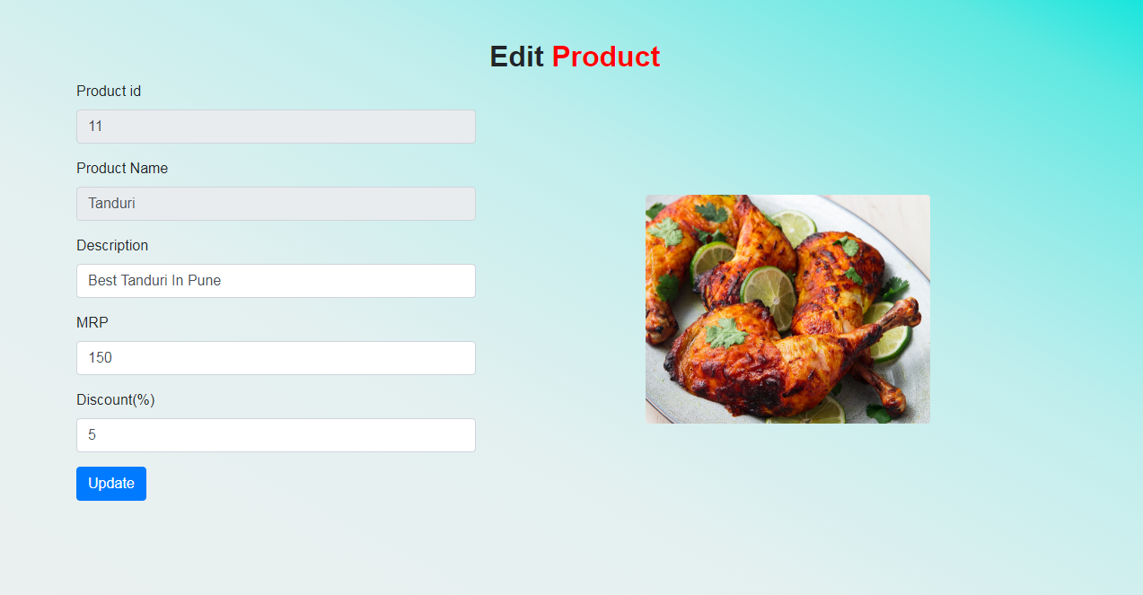

Waiting Orders

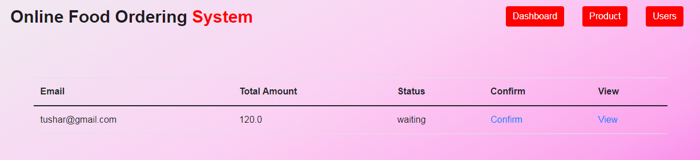

View order

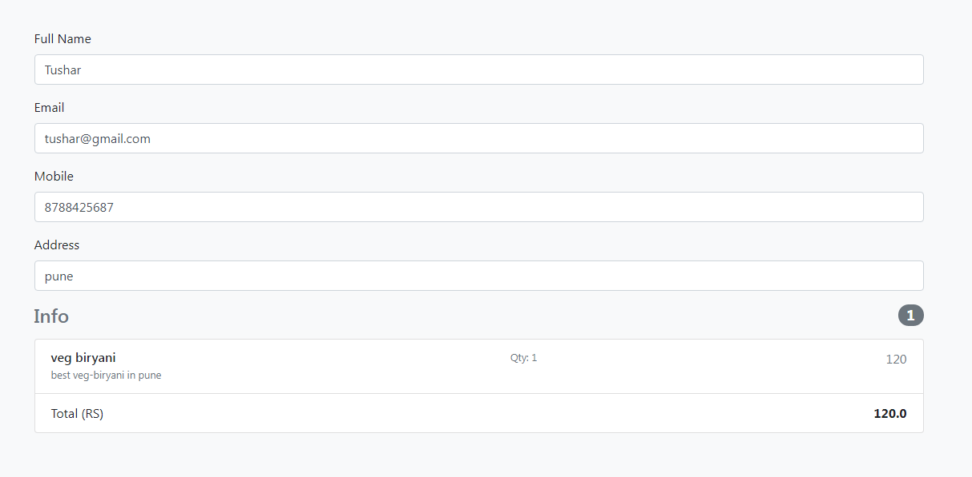

Successful order

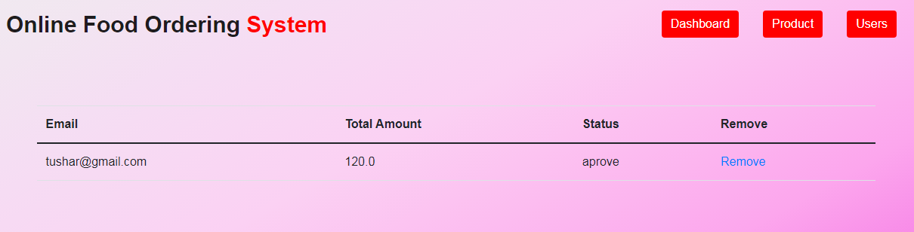

User Side

Homepage

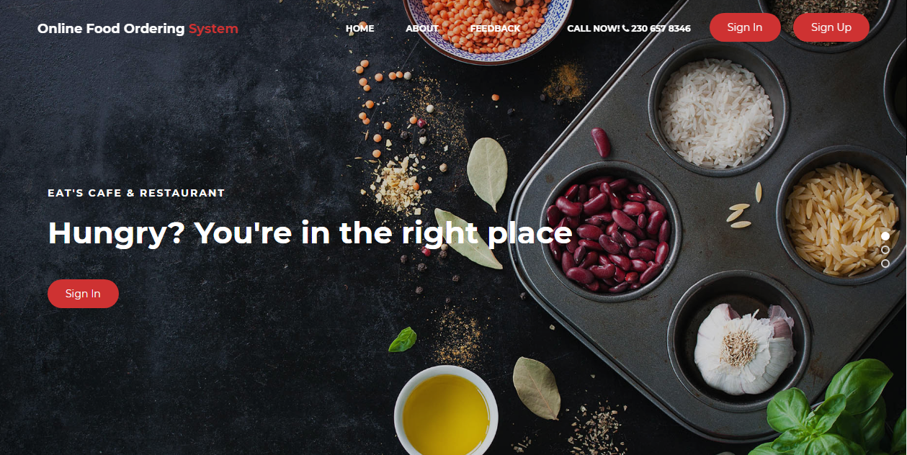

Login Page

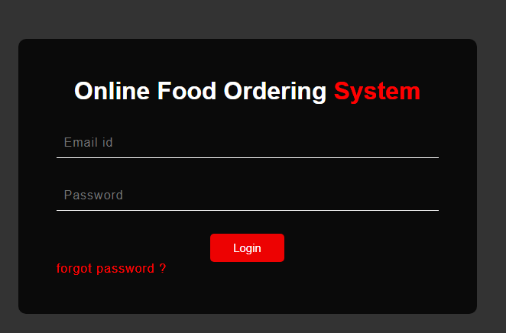

Signup page

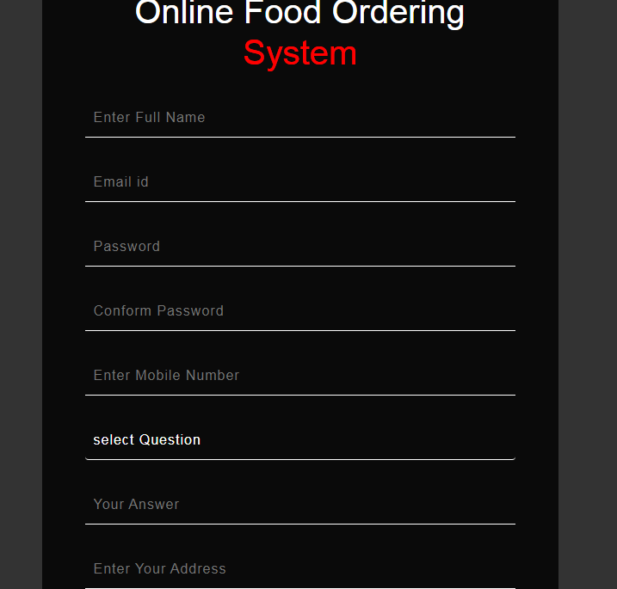

Forgot password page

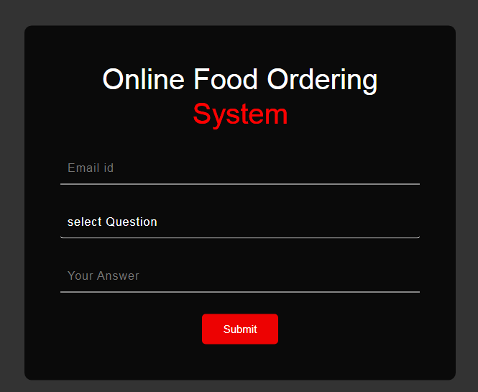

Dashboard

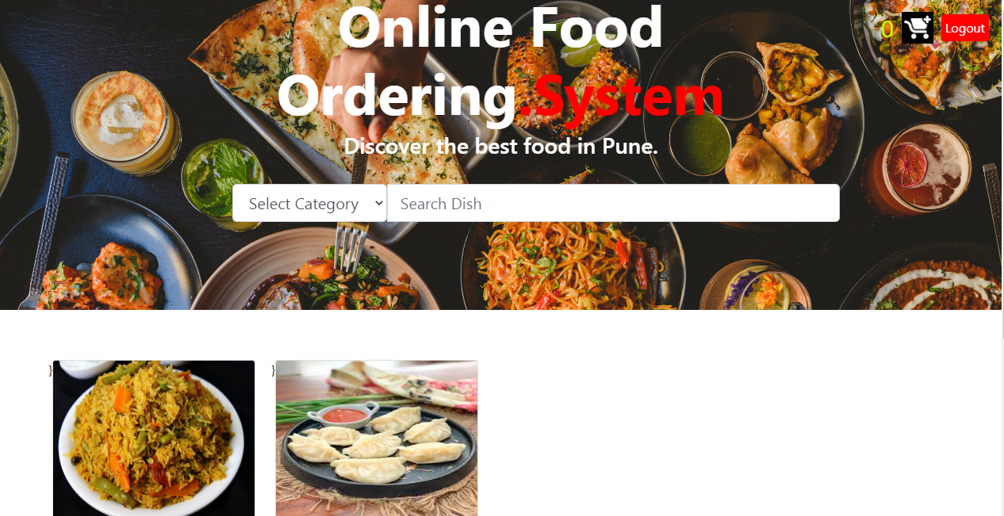

Cart

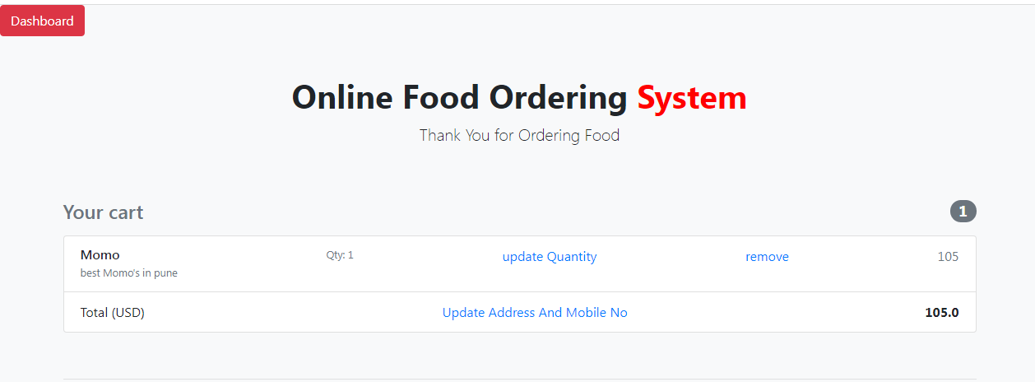

Payment

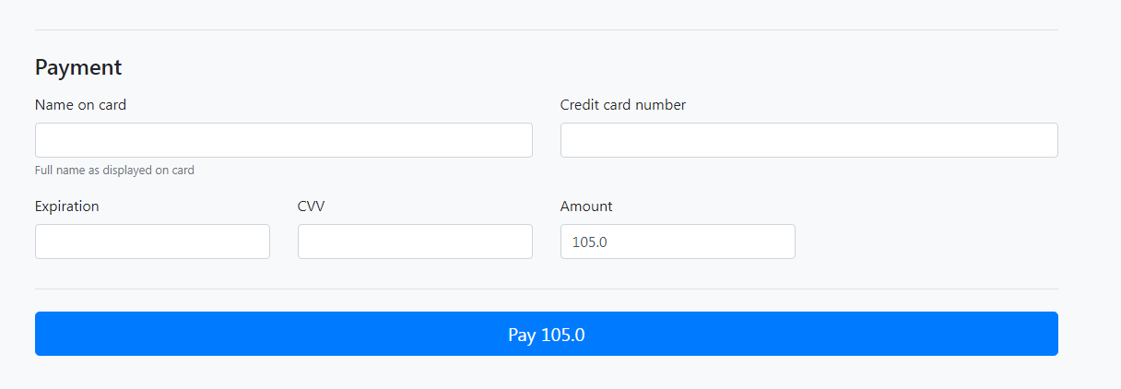

Feedback

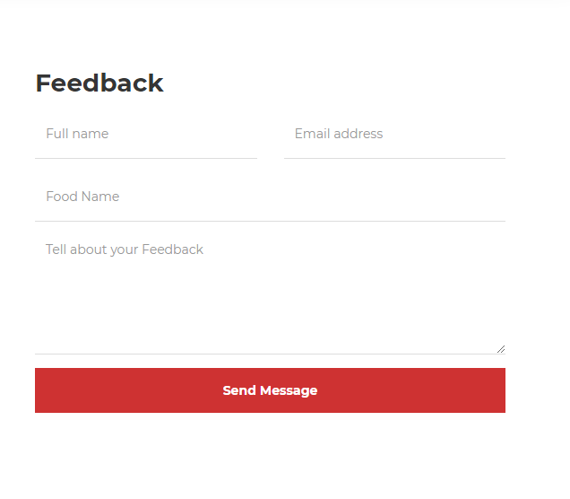

**4.3 Sample program code**

User Dashboard

dashboard.jsp

<%@ page language=*"java"* contentType=*"text/html; charset=ISO-8859-1"*

pageEncoding=*"ISO-8859-1"*%>

<%

**if**(session.getAttribute("auname")==**null**)

{

response.sendRedirect("../login.html");

}

%>

<!DOCTYPE html>

<html>

<head>

<meta charset=*"ISO-8859-1"*>

<title>Dashboard</title>

<link rel=*"shortcut icon"* href=*"../images/icon2.jpg"*>

<link rel=*"stylesheet"* href=*"https://cdn.jsdelivr.net/npm/bootstrap@4.6.0/dist/css/bootstrap.min.css"* integrity=*"sha384-B0vP5xmATw1+K9KRQjQERJvTumQW0nPEzvF6L/Z6nronJ3oUOFUFpCjEUQouq2+l"* crossorigin=*"anonymous"*>

<script

src=*"https://ajax.googleapis.com/ajax/libs/jquery/3.6.0/jquery.min.js"*></script>

<style>

*.footer* {

left: *0*;

bottom: *0*;

width: *100%*;

font-size:*15px*;

background-color: *black*;

color: *#fff*;

text-align: *center*;

padding:*7px*;

}

</style>

<script type=*"text/javascript"*>

**function** allfun()

{

displayproduct()

showcount();

}

//display all product

**function** displayproduct()

{

// display all food

ob=**new** XMLHttpRequest();

ob.open("GET","displayproduct.jsp");

ob.send();

ob.onreadystatechange=**function**()

{

**if**(ob.status==200 && ob.readyState==4)

{

document.getElementById("output").innerHTML=ob.responseText;

}

}

}

**function** txtselect()

{

str=document.getElementById("txtselect").value;

ob=**new** XMLHttpRequest();

ob.open("GET","display_pro_cat.jsp?cat="+str);

ob.send();

ob.onreadystatechange=**function**(){

**if**(ob.status==200 && ob.readyState==4)

{

document.getElementById("output").innerHTML=ob.responseText;

}

}

}

**function** search()

{

str=document.getElementById("txtsearch").value;

ob=**new** XMLHttpRequest();

ob.open("GET","search_product.jsp?pro="+str);

ob.send();

ob.onreadystatechange=**function**(){

**if**(ob.status==200 && ob.readyState==4)

{

document.getElementById("output").innerHTML=ob.responseText;

}

}

}

**function** showcount()

{

ob1=**new** XMLHttpRequest();

ob1.open("GET","showcount.jsp");

ob1.send();

ob1.onreadystatechange=**function**(){

**if**(ob1.status==200 && ob1.readyState==4)

{

document.getElementById("showcart").innerHTML=ob1.responseText;

}

}

}

</script>

<style>

*.container*

{

margin-top:*5%*;

}

</style>

</head>

<body onload="allfun()">

<nav class=*"navbar navbar-expand-sm fixed-top navbar-light justify-content-between"*> <!-- This Line Make nav bar Trasperent -->

<a class=*"navbar-brand"*></a>

<form class=*"form-inline"*>

<a href=*"showcart.jsp"* id=*"showcart"* style="color:*#c4ff03*; font-size:*30px*">0</a> <!-- Counter -->

<a href=*"showcart.jsp"* ><img alt=*"tt"* src=*"images/cart1.png"*style="margin:*10px*" height=*40;*></a>

<a class=*"btn btn-primary m btn-outline-success my-2 my-sm-0"* href=*"Logout.jsp"* style="background:*red*;color:*#fff*;border:*none*;padding:*5px*;" role=*"button"*>Logout</a>

</form>

</nav>

<div style="width: *100%*; height: *60vh*;overflow: *hidden*;" id=*"carouselExampleCaptions"* class=*"carousel slide"* data-bs-ride=*"carousel"*>

<div class=*"carousel-inner"*>

<div class=*"carousel-item active"*>

<img src=*"images/bg.jpg"*class=*"d-block w-100"* alt=*"..."* style="width: *100%*;"> <!-- src="images/bg.jpg" -->

<div class=*"carousel-caption d-none d-md-block"* style="padding-bottom: *39%*;">

<form class=*"form-inline"* style="width-left:;">

</form>

<!-- <a><img alt="" src="images/add to cart.png"></a> -->

<h2 class=*"display-3 font-weight-bold"*><b>Online Food Ordering<span style="color:*red*;">.System</span></b></h2>

<h3 style="padding-bottom: *10px*">Discover the best food in Pune.</h3>

<div class=*"input-group mb-3"* style="width:*90%*; margin-left:*10%*;padding:*15px*;">

<!--

<form class="form-inline m" style="width-left:90%;">

<a class="btn btn-primary m" href="logout.jsp" style="background:red;color:#fff;border:none;" role="button">Logout</a>

<a><img></a>

</form>

-->

<div class=*"form-group"*>

<select class=*"form-control form-control-lg"* id=*"txtselect"* onclick="txtselect()">

<option selected>Select Category</option>

<option value=*"veg"*>Veg Items</option>

<option value=*"non veg"*>Non Veg Items</option>

</select>

</div>

<input type=*"text"* class=*"form-control form-control-lg"* placeholder=*"Search Dish"* id=*"txtsearch"* onkeyup="search()">

</div>

</div>

</div>

</div>

</div>

<div class=*"container"* >

<div class=*"row"* id=*"output"*>

</div>

</div>

<div class=*"footer"*>

<p color=*"white;"*>This Site Is Developed By : Tushar R. Jagtap (Sinhagad Institute of Management)</p>

</div>

</body>

</html>

Admin Dashboard

AdminDashboardH.jsp

<%@ page language=*"java"* contentType=*"text/html; charset=ISO-8859-1"*

pageEncoding=*"ISO-8859-1"*%>

<%

**if**(session.getAttribute("auname")==**null**)

{

response.sendRedirect("login.html");

}

%>

<!DOCTYPE html>

<html>

<head>

<meta charset=*"ISO-8859-1"*>

<title>Admin_Dashboard</title>

<link rel=*"shortcut icon"* href=*"image/a.png"*>

<link rel=*"stylesheet"* href=*"https://cdn.jsdelivr.net/npm/bootstrap@4.6.0/dist/css/bootstrap.min.css"*>

<style type=*"text/css"*>

*.footer* {

left: *0*;

bottom: *0*;

width: *100%*;

font-size:*15px*;

background-color: *black*;

color: *#fff*;

text-align: *center*;

padding:*7px*;

}

</style>

<script type=*"text/javascript"*>

**function** fun()

{

totalproduct();

totalfeedback();

totaluser();

//ordercount();

//successorder();

}

**function** totaluser()

{

obj=**new** XMLHttpRequest();

obj.open("GET","totaluser.jsp");

obj.send();

obj.onreadystatechange=**function**()

{

**if**(obj.status==200 && obj.readyState==4)

{

document.getElementById("tuser").innerHTML=obj.responseText;

}

}

}

**function** totalfeedback()

{

ob=**new** XMLHttpRequest();

ob.open("GET","totalfeedback.jsp");

ob.send();

ob.onreadystatechange=**function**()

{

**if**(ob.status==200 && ob.readyState==4)

{

document.getElementById("tfeedback").innerHTML=ob.responseText;

}

}

}

**function** totalproduct()

{

obp=**new** XMLHttpRequest();

obp.open("GET","totalproduct.jsp");

obp.send();

obp.onreadystatechange=**function**()

{

**if**(obp.status==200 && obp.readyState==4)

{

//alert(ob.responseText);

document.getElementById("tproduct").innerHTML=obp.responseText;

}

}

}

</script>

</head>

<body onload="fun()">

<nav class=*"navbar navbar-light"*>

<a class=*"navbar-brand "*><b><h2 class=*"font-weight-bold"*>Online Food Ordering <span style="color:*red*"> System </span></h2></b></a>

<form class=*"form-inline m"* style="">

<a class=*"btn btn-primary m"* href=*"../Admin/logout.jsp"* style="background:*red*;border:*none*;" role=*"button"*>Logout</a>

</form>

</nav>

<div class=*"container mb-2"*>

<!-- first Row -->

<div class=*"row mt-4"*>

<!-- first col -->

<div class=*"col-sm-4"*>

<div class=*"card text-center"*>

<div class=*"card-body"*>

<div class=*"container"*>

<img style="max-width:*125px*" class=*"img-fluid rounded-circle"* alt=*"user icon"* src=*"image/user.png"*>

</div>

<h1 id=*"tuser"* onload="totaluser()"></h1>

<h1 class=*"text-uppercase text-muted"*>User</h1>

<div class=*"container"*>

<a href=*"usershow/alluserH.jsp"* class=*"btn btn-primary"*>Users</a>

</div>

</div>

</div>

</div>

<!-- secound col -->

<div class=*"col-sm-4"*>

<div class=*"card text-center"*>

<div class=*"card-body"*>

<div class=*"container"*>

<img style="max-width:*125px*" class=*"img-fluid rounded-circle"* alt=*"feedback_icon"* src=*"image/feedback.png"*>

</div>

<h1 id=*"tfeedback"*></h1>

<h1 class=*"text-uppercase text-muted"*>Feedbacks</h1>

<div class=*"container"*>

<a href=*"feedback/FeedbackH.jsp"* class=*"btn btn-primary"*>Feedback</a>

</div>

</div>

</div>

</div>

<!-- third col -->

<div class=*"col-sm-4"*>

<div class=*"card text-center"*>

<div class=*"card-body"*>

<div class=*"container"*>

<img style="max-width:*125px*" class=*"img-fluid "* alt=*"eror icon"* src=*"image/product.png"*>

</div>

<h1 id=*"tproduct"*></h1>

<h1 class=*"text-uppercase text-muted"*>Products</h1>

<div class=*"container"*>

<a href=*"product/addproductH.jsp"* class=*"btn btn-primary"*>Add Product</a>

</div>

</div>

</div>

</div>

</div>

<!-- Secound Row -->

<div class=*"row mt-4"*>

<div class=*"col-sm-6"*>

<div class=*"card text-center"*>

<div class=*"card-body"*>

<div class=*"container"*>

<img style="max-width:*125px*" class=*"img-fluid rounded-circle"* alt=*"user icon"* src=*"image/order.png"*>

</div>

<h1 id=*"torder"*></h1>

<h1 class=*"text-uppercase text-muted"*>Waiting Orders</h1>

<div class=*"container"*>

<a href=*"product/conform_orderH.jsp"* class=*"btn btn-primary"*>Confirm Order</a>

</div>

</div>

</div>

</div>

<div class=*"col-sm-6"*>

<div class=*"card text-center"*>

<div class=*"card-body"*>

<div class=*"container"*>

<img style="max-width:*125px*" class=*"img-fluid rounded-circle"* alt=*"user icon"* src=*"image/rupee.png"*>

</div>

<h1 id=*successfull*></h1>

<h1 class=*"text-uppercase text-muted"*>Successfull Orders</h1>

<div class=*"container"*>

<a href=*"product/success_order.jsp"* class=*"btn btn-primary"*>Successfull</a>

</div>

</div>

</div>

</div>

</div>

</div>

<div class=*"footer"*>

<p>This Site Is Developed By : Tushar R. Jagtap (Sinhagad Institute of Management)</p>

</div>

</body>

</html>

4.3 Limitations and Bibliography

Bibliography

* <https://www.w3schools.com/>
* <https://www.youtube.com/watch?v=xve6QEgIR-0&list=PL0zysOflRCel5BSXoslpfDawe8FyyOSZb>
* <https://www.javatpoint.com/>
* <https://www.geeksforgeeks.org/>

Limitations

* This web app for only one hotel
* Payment in Dummy mode only
* Customer cannot view order history